Draft Regen Proposal: Summary
This is an attempt to provide a long-term, practical, vision of how Regen Culture can become integrated into group identity, decision making, and the effective use of their time and energy.
The whole movement participates in Actions. Where does Regen fit? Answer: it is not separate, and yet, we talk about it as if it were. So how do groups become more intentional about their own regen? Regen is not a thing you do; it is a way of organising your life so that you do not burnout in pursuance of your goals. Regen in practice is just a name for the decisions you make, the things you do, and the ways you do it. To work regeneratively is think about who we are and what we want to do, then, to consider our capacities and energy, to ensure that, as we go, we do not fall apart. In XR, regenerative practice can refer to a process, whereby a part of the movement takes careful account of group energy and capacity and, incorporating certain considerations such as group mandate, group capacity, desires, and need for self-care, and out of which, the group makes decisions about what they do and how they do it. The more fundamental effects of these decisions are care for each other (Non-Violent Communication) and intentionality in the organisation of group energy. Regen is about ‘time’: what we do, when we do it, and how much effort we expend in doing so. Hence, awareness of Regen is not just about having a spokesperson but is also concerned with a group making good decisions. It means taking account of a range of considerations, before the group decides how to organise their calendar. Considering this, I propose that, a regenerative way of working is for Local/ Working/ Affinity groups to get together to take time to reflect on who they are, what they want to achieve and to take careful account of their capacity and, from these considerations, decide how they want to use their time. Basically, Regenerative practice helps a group develop a calendar together. The group can populate it in any way they wish. It can include actions, events etc. in a way that is more intentional, and takes a careful account of their own needs. From this organisation of time, a group will have made decisions with greater data and clearer intentionality. In general, my suggestion is that we can integrate regen into XR culture, if we attend carefully and reflectively, into how we use our time (our energy).

Example: How we could do this
A Local Group such as The Mornington Peninsula, sets up a meeting where they want to reflect on their history, present and future. The practical outcome is to generate a schedule of things they want to do through the year. The first thing is to have a volunteer to lead the group through a reflection: take some time to reflect on who they are, where they have come, what they have learned over the past:

Reflection: Where we have come from and where we are going?
Where have we come from (tell the story of the group)?
What have we learned?
Who are they as a group (mandate, but also, who do we want to be as a group?).
What do they want to do (what do they want to achieve?)?
What things do they need to be careful of (what are some challenges that the group needs to be aware of?)?
How do they want to achieve this?
The answers can draw on the group’s input and can range from a Social or Environmental Justice focus or Regen or any combination. The main thing is that the process is reflective, meditative, and joyful, rather than proforma.
Regen and time: This section asks: How would we like to use our time over the next few months?
Consider these questions in no particular order: What are some things we would like to do for ourselves?
What would we like to contribute to the movement?
How would we like to save the world?
What would we like to do for our community?
Produce the schedule: this is more proforma, it can take place over two or more meetings or through whatever means the group thinks will work.

Argument:
- XR is a Self-Initiating Movement.
  - It is a movement that takes responsibility for the climate apocalypse causes mass CD in order to cause governments and business to stop carbon emissions.
  - The problem is that the conditions of motivation for (1) (Government inaction on Climate Change) are constant and rarely vary. Governments and businesses are not divesting quickly enough to prevent climate catastrophe, and therefore XR, as a protest movement, always has reasons to protest.
- As such, XR working groups are always responsible for initiating Actions and Regen, this is a positive thing, because no one individual is responsible for one element of the movement, exclusively, but responsibility for the movement is shared by all.
- However, when groups experience stress, in my view, they become conservative, meaning that they are unlikely to make dramatic changes to their practices or thinking, they are unlikely to suggest changing their structures to accommodate change. In my experience, groups are more likely to either maintain their habitual stance, whatever that is, or simply stop the habit, without implementing an alternative.
  - An example being, that if a group is predominantly activist, when faced with an absence of action, it is likely to fill that gap with more actions, or simply dissolve.
- What is the most important characteristic of a local/ Working group? However, working groups are not just about relationships, they meet in order to undertake actions, in other words, they meet to organize time. Therefore, a good way for groups to share in a regenerative process is to organize their time together.
- Given what we have seen from the last year or so, Regen begins with what is most immediate, communication, relationships etc.
- Rather than Regen being a matter of a regen advocate, regen can, in part, be a collective process.
- Therefore, a regen action/ suggestion that I am making, is that working/ local groups, get together, and discuss how they want to organize their time.
  - The schedule can allow groups to include explicit ‘Regen’ time that become part of what the local or working group schedules for itself.
  - This will have the following benefits: Every participant in the process can take responsibility for the outcomes.
The ‘Regen’ advocate, is simply that person (any person) who is taking responsibility for coordinating the scheduled Regen activity, rather than a person with specialist training.

Short Essay: A problem of revolutions:
What are themes that comes up consistently within revolutions is the following: every large group of political radicals, not matter how well organized they are for Revolution, always find themselves in situations that they are unable to control. The most successful groups are those who can respond effectively to the internal and externally events that arise within their purview. The qualification of this is that most revolutionary movements takes years to mature before they win. What makes them able to be successful in prosecuting their ideals? One reason it seems to me is that many of these movements do not always actively pursue revolutionary activity at all times but maintain a state of readiness, mediated by group connection, support and even leisure, which provides a context for them that prepares them for any eventuality so that they are able to respond. Long-term revolutionary activity is not just about being constantly active, or even constantly preparing for action, but of a group having ways to balance the active and the passive moments that constitute their lives. What does readiness consist of? In many cases in the history, readiness has consisted of holding certain political views having certain tactics having a certain body of material or persons who are able to prosecute the actions themselves, but primarily, readiness refers to the capacity of a group to act in response to the thing they are fighting.
There are external circumstances which stimulate these types of activities to emerge such as policy mistakes political mistakes political actions or law mistakes of law. As such, some aspects of revolutionary activity do not necessarily activate unless there arise external circumstances which permit them to do so. In other words, groups prepare their ideas, maintain their community, their policies their ideals and material; they then can respond to those threats to those ideals materials etc. However, our revolution has its own issues, and we have responded to these issues in a particular way, with particular success, but the successes have also had some effects on our community.

A Problem of Our Revolution
Now XR has clear political concerns and clear policy concerns and clear fights to undertake. Each of these policies and fights etc. are protesting existent policies. These policies or political views constantly activated by the circumstances that we find ourselves in nationally and internationally. That is to say because we have set ourselves against climate change policies but because these climate change policies are ubiquitous, ever-present injustice that is constant, we find ourselves constantly fighting against a the same enemy again and again and again. Moreover, because the state of injustice is normative, then it leaves us with the problem that we always have a source for undertaking actions. We do exercise some discernment, but the source of our actions are, for the most part, ourselves, in which we enact a response against a normative state of climate injustice. Rather than waiting for circumstances to rise to permit us to act we act always according to our own energies. After a while this becomes exhausting. The combination of these elements leaves us constantly drained because our state of readiness dictates that there is not one specific circumstance more than another that will call us out into action.
This has meant the following: XR is always activated, because the circumstances we are fighting against are always present. We are always in a constant state of readiness. Second, that the criteria for us ceasing our activity, though clear, are, for all intents and purposes, infinite so long as the system remains, the game is never won. I’ll note that many successful CD movements had a general mandate which could be described in a number of ways (Equality for Black Americans), which entail moving between protesting specific policies (school segregation in Alabama) or a general CD action (the Million Man March). XR might want to consider a similar organization between general and specific.
It is in effect, we are playing a game whose criteria for winning are well defined (it seems like a finite game) but in fact, because the criteria are so large, that we are playing an infinite game. In game theory, these circumstances are as if we are in an unwinnable game. If we continue like this in a state of constant action we will find ourselves in a situation of continual readiness continual action with no circumstances under which pauses are required except those initiated by a group who’s habits are determined by a cycle of activism.
https://www.youtube.com/watch?v=SdRqkO89IAE
Effectively, by XR constantly using only its own internal energy not only determining actions, but also rest, the circumstances lead to the Homer scenario, where, for all intents and purposes, despite changes of quality of energy, both rest and activism, effectively, are arising from the same group. The drain of energy causes burnouts and, over time, causes groups to either become dysfunctional or cease to function all together. This causes us to lose people and momentum.
Although Regen (here just meaning the activity of restorative resting rather than any specific practices of Regen) is an aspect of XR, Regen is often an activity that must be initiated by some part of the local group. This means that the stimulus for action and for regen, are often coming from the same group of people. Why is this a problem? If energy is required for two different things, even if one thing is actively necessary for maintaining the other, a group faced with a need to initiate a regenerative activity, will, rather than choosing a activity (Regen) that supports another activity (Activism), in my experience, the group will not divert energy from their habitual practices (Activism), but simply reduce the number of activities they undertake. The effect is that, rather than resting, the group just not shift its intention, but simply continues at a slower pace. In order to provide some assistance so that groups are not always charged with the responsibility of initiating certain actions (whether Regen time or Activism), that a group generate some guidelines for when actions are undertaken, how they are done etc. In other words, to set some guidelines out so that the group does not either burn itself out or become completely inactive. Before I discuss these, I’ll refer to Regen’s story in Victoria.

Who is Regen?
In terms of XR, Regen is two things, it is a way of organizing activism so that our crew don’t burn out, second, it is our attempt to live out of a culture that transforms society and prevents us from being enmeshed in the patterns of behavior that have caused the ecological and social break-down which are bringing our world to the brink of collapse. In terms of how this plays out in practice, Regen is an evolving thing, it has an evolving mandate, its actions and responsibilities are constantly shifting to meet the needs of the movement. By way of explanation, I’ll tell a story about how Regen seems to be developing in XR. My observations are based on some foundational documents, but mainly based on my observations of how Regen, as a part of the movement, responded to events as they arose. I will argue that, through time, this exposed a well-known debate about what the XR movement is, and how it should go forward. I argue that, although the founding of XR sought to place Regenerative Culture as coequal to activism of the movement’s mass civil disobedience, in effect, CD takes priority over Regen.
Regen has a mandate for Actions support, but a further aspect of Regen is its focus on providing a structure of longer-term support for the XR community. This aspect of the Regen mandate are things such as ‘Meditation and Well-Being’ for activists, facilitation and other elements. This has been demonstrated in how the mandate of Regen in parts of the UK, Victoria, and NSW, were focused on: Actions support, Conflict Resolution or Non-Violent Communication and Arrestee Support. These three have a common factor: they are responding to specific circumstances (actions, conflicts or Arrests) that arise as a result of CD actions. CD helped generate strains between members of the movement, helped created tensions within local and working groups, and caused arrests. The second element arising from this analysis is that Regen has a mandate for triage, a form of Activist first responder. One insight this gave me was that Regen is not just long-term well-being, but clear communication, community harmony, and support for the most vulnerable (Arrestees). These factors above demonstrate that A) part of Regen is to discover its mandate and that B) regen mandate includes responding to the immediate needs of the communities. The main negative of this is that, with all of these shifts in energy, Regen working groups become drained, this slow draining has caused significant burnout in Victoria and no doubt other areas. Arguably, an important reason for this burnout is that Regen in Victoria has been too centralized, we had been attempting to decentralize over the past three months, and had initiated processes to do so, but had struggled to cope with this process simultaneously with our preparation for the, now suspended, rebellion in May. All these learning experiences occurred under my watch as co-coordinator of Regen in Victoria. The story describes a process of Regen responding to the predominant energy of the movement: Civil Disobedience, because the energy of CD is, as discussed in the previous section, a response to a situation that is often (for all intents and purposes) normative, our energy is originates internally. Eventually, if we cannot control the circumstances that activate us (the government does not shift policy) then we will find ourselves burning out. Therefore, we need mechanisms for groups to take control of how they use their time and energy.

Practical Steps

Part 1: Implementing Regen into General Group Culture in XR Vic
See example on first pager. Strangely perhaps, Religious communities are the most enduring examples of intentional communities. They are also formed by two powerful elements that resonate with XR: A mission and personal and cooperative enthusiasm. The problem is that these two elements and produce significant strain on the community. As such, through early religious movements, they gather around a mission, a sense of purpose, but establish some guidelines to help the community moderate their energy. Guidelines can be very loose, agreed by the group, that articulate what they group does and why. These guidelines help a group decide what their mandate is (why they are there) and when or when not to do something. In other words, one of the best ways the group can sustain themselves (apart from gathering frequently) is to organize how they use their time.
A schedule consists on specific events that the group has chosen to fill their time with. Once it has been designed, there can be modifications, but the idea is that the schedule provides a group with a mechanism which means that individual and group energy alone are not the sole source of every action. It creates a circumstance that permit a group to rest, even if our energy wants to continue, to act, even when this is uncomfortable, and undertake reflection in a time that seems to need something else. Counterintuitive though it might be, this approach has been enormously successful for building sustainable communities. Meditation provides a good example. If I only meditate according to my moods, then sometimes, if I don’t feel like meditating, I won’t, and sometimes when I feel like meditating, but shouldn’t (I have something to do), I will. But most mindfulness programs with demonstrated success for the treatment of depression and anxiety, maintain a two things: 1 consistent focus in the meditation (during the sit) so that the mind does not wander into joy or despair, 2) a consistent dosage, a consistent amount of meditation, applied every day no matter whether the person feels like they need to. 3) Maintaining the practice over an extended period. In a community setting: Most long-established Religious communities maintain harmony, not just by having a common vision, but establishing customs that regulate how individuals use their time. They have a meditation practice, maintain this practice using a schedule agreed by the community, as well as free time (opportunities for self-expression). This schedule organizes time for the explicit purpose: not leaving meditation at the whims of personal or even group energy. Instead, they follow a schedule that is sufficiently varied, to allow that the various propensities of the community are met: everyone needs to eat, sleep, work and meditate, but sufficiently open so that if someone prefers to work with their hands, or study, or meditate, in the time outside the schedule, they can do whatever they like.

Relationship to Regen Cycle
The Regen Action Cycle was designed to provide a cycle for working groups so that they can have a way of approaching actions in such a way to eliminate burnout and produce a conducive environment in and around actions. The cycle was an attempt to provide a way of ensuring the health of members of the movement. If applied, the cycle can be a way of building up and retaining energy. However, the Regen cycle is organized around actions, which means that actions are the main organizing principle for how the Regen cycle is employed. In this way, it provides triage, rather than representing a positive for how we use our time. Slowing down is not just about having a long gap between the same thing, it is about altering the quality of our lives, moving out of a routine so that we can gain perspective. Space, even boredom, can be extremely creative, but only if they stand on their own and not as a bridge to something else.

Relationship to S.O.S. Culture
S.O.S. refers to processes and practices that attempt to create a harmonious and sustainable group environment. It focuses on several key components for group dynamics including meetings, decision making and consensus, and communication. The main focal point of S.O.S., therefore, is the organization and flow of meetings (the point where people meet and talk through things with each other). S.O.S. focuses on the locations where decisions, communication are being made: meetings. The idea is that if each meeting possesses conditions of well-being, consensus, and group harmony, then resulting practices will retain these similar conditions. This is true. If S.O.S. Principles are maintained, it is likely that groups will make better decisions, be more harmonious, and have greater well-being and resilience. However, although the framework for articulating S.O.S. is mainly based around the meeting as the primary point at which these practices prove effective, and while this is true, with respect to meetings, well-being, harmony and resilience to conflict also depend on broader factors: personal energy, group dynamic, burnout. The consideration of a group dynamic must also consider the longer term elements that contribute to a group’s self-understanding: its mandate, its direction, and the use of its time.
Hence, I argue that, part of S.O.S. should consider how to bring consensus-based approaches to the examination of the long-term health of the group. To do this, we need to have a mechanism for developing group identity, harmony, and resilience over the long-term. As mentioned, the most practical way of doing this is top employ: 1) reflection and 2) S.O.S. principles but directed to examine how groups plan their time (long-term schedule).

Part 2: Using Mandates as a Point for Group Reflection
Mandates are not just statements about the responsibilities of the groups within the movement, they are also part of our identity. Although the administrative side is important, it is worth groups taking time to reflect on who they are and why they are doing what they are doing. The idea is that, undertaking a reflective engagement with a mandate or an identity of a group is to show that reflection can be a productive way of shaping the identity of the movement not only in terms of actions, but also how the group itself, comes together as friends and activists. In practical terms, mandates already set out how we make decisions, who is responsible for what, and the limits of group capacities, I suggest that reflecting on these factors can create an environment that utilises its time with more careful and intentional energy. Moreover, this consideration can inform part 1): how we use our time, and part 3): how a group decide whether to take up ‘external’ requests and opportunities, or to place them aside.

Part 3: Responding to Opportunity: Making Decisions Reflectively
From experience some thoughts leave us sad while others leave us happy, little by little we come to discern a pattern in this. As we consider possibilities, we can start to take note of how we are responding to the possibility. No matter how objectively good an opportunity might be, if we simply do everything that seems good, over time, our energy will be dissipated. On the other hand, if we take time to consider the opportunity and reflect on our feelings, our decision making will be able to take in a fuller range of experiences: our energy, enthusiasm, previous experience, our imagination (fantasies) and our identity. Experience is not just the world, but our relationship with the world, with ourselves and with each other. Because of the complex elements involved in deciding about what we do or do not do, it is important to take time to reflect on the situation.
Our feelings can be complex, sometimes what makes us feel anxious initially, can conceal deeper feelings of ‘I need to do this’. Other feelings might be: “I should do this”, but as we sit with the feelings a little longer, we see that the feelings are leftovers from our past, and are actually not authentic responses to what is happening now. Some of our feelings can deceive us, others reveal something true and authentic. However, because of the consequences of our decisions, it is worth setting up decision making, not just as a single moment, but as something that evolves over time. The challenge is to sit with these feelings so that we can get a clear idea of how they are affecting us, and whether these feelings are showing us an opportunity that we should take up, or a distraction that we place aside.
If an important decision needs to be made, then, I suggest breaking the decision making process down into small steps.
Different events trigger certain types of responses in us; of our responses show feelings of excitement, joy, anxiety, or sadness.
(Autobiography, no. 8).

Appendix: Diagram:
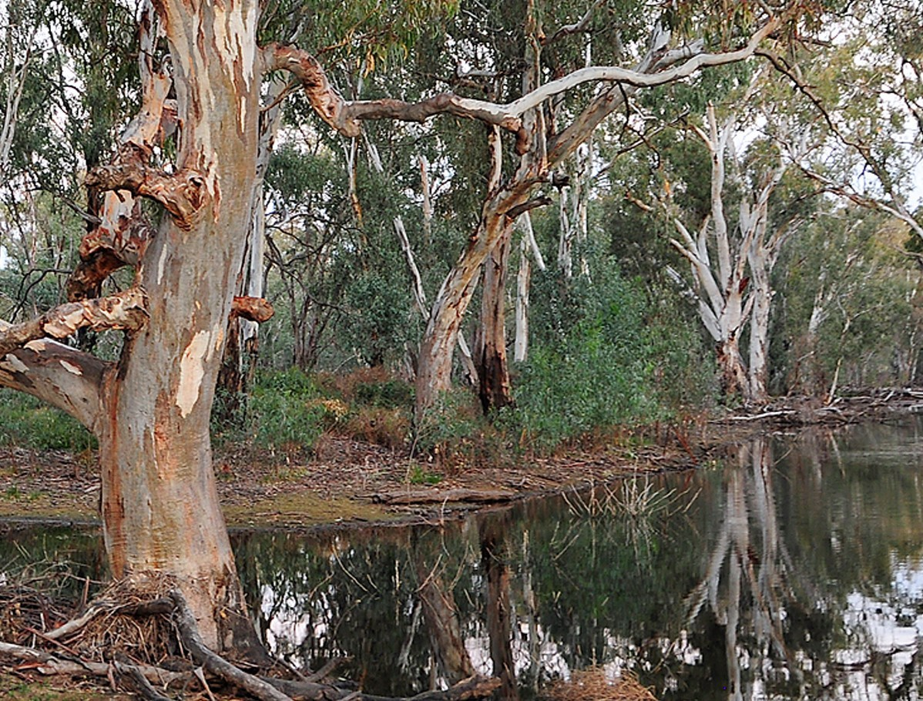

Appendix: Analytical Argument
Normativity in general and in time:
In general: A = A (Indefinitely) or A∫. The effect being: A= A∞. If A= a value (1) then this value (1) neither increases or decreases in value.
As Time: As depiction as a form of time in which no variation occurs, then time is not A to B. In a normative state A =A ∞, or: A ∫ (indefinite).
XR’s Problem:
XR functionally intervenes in a normative space (A) by way of their own energy (E), which means that instead of A∞ XR has initiated (E), for all intents and purposes: E ∞ as an attempt to contrast with the normative. In other words, XR has attempted to operate in reaction to the normative and attempted to change what is, at present, a normative situation, this is not sustainable as it has set up a two opposing which are theorized to be of equal size, but which are, evidently, not of equal size.
Proposed Solution:
XR change how it focuses its internal energy, rather than being continuously activated by the normative state, we exercise an internally generative set of variations in how we organize our time. XR groups simply fill their timeline in a manner that fits their own internal desires and capacities (in contrasts with attempting to meet the normative as the normative).
We create our own form of life: A, B, C, D etc. and our own form of Time: A________ B ________ C________ D etc. Effectively, we begin to operate out of finite, rather than indefinite, sense of time.
This means designing time to allow for variations: We have a CD action every 3 months, we have a Regen Action or event every month.
Each WG, AG or LG undertake a process to develop a timeline. This is one practical way that XR can undertake mass acts of CD, in a way that preserves our energy.

https://www.ignatianspirituality.com/making-good-decisions/discernment-of-spirits/introduction-to-discernment-of-spirits/ Accessed 9/05/2020.

