missing
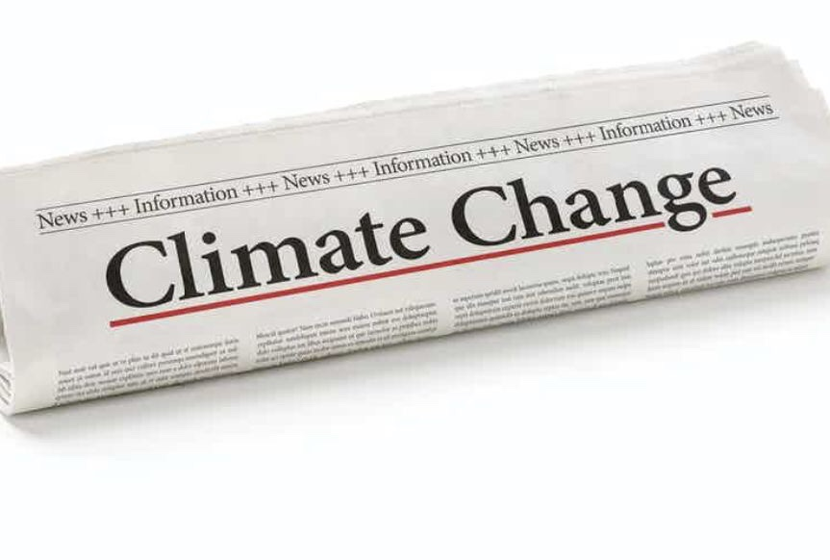
Our good friend, climate change news, is lost!!!
It used to warn us about the climate emergency but now it’s nowhere to be seen.
Many serious climate events are happening right now but they’re not being reported. Our climate scientists say that extreme heat is going to increase & cause floods, sea level rise, heatwaves, bushfires & more. When the scientists are worried, shouldn’t we be worried too?
We need to have a national conversation about it. But how can we when it’s not being reported?!?!?

JOIN EXTINCTION REBELLION & DEMAND THAT THE MEDIA TELL THE TRUTH about THE CLIMATE CRISIS!

https://ausrebellion.earth/

https://ausrebellion.earth/

https://ausrebellion.earth/

https://ausrebellion.earth/

https://ausrebellion.earth/

https://ausrebellion.earth/

